Simulation Experiment 2
Design and Implementation of VLAN Segmentation and Inter-VLAN Routing for a Multi-Department Network using Cisco Packet Tracer Major
Objective 1: VLAN Configuration

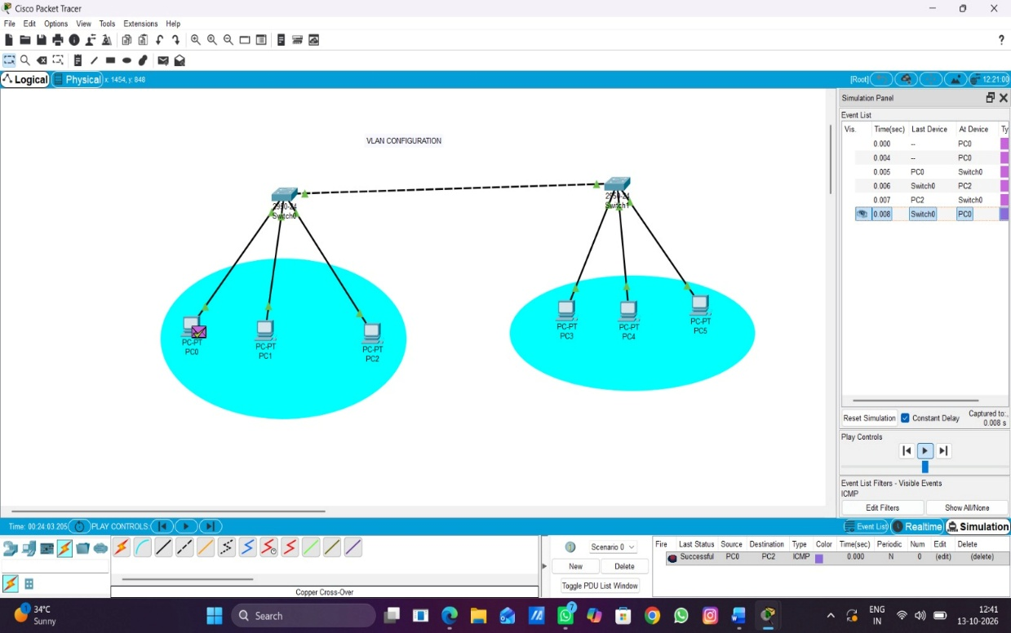
Objective 2: Inter-VLAN configuration
